
Introduction to DOSBox
Pre Final Lab

Computer Organization and Assembly Language

Student Name | Muhammad Hassan Khalid
Registration # | 21L-5692
Instructor | Hazoor Ahmad
Class | CS3
Section | A1, A2, D1, D2
Semester | Fall 2022

Fast School of Computing
FAST-NU, Lahore, Pakistan

Activity 1

Assembly Language Code
[org 0x0100]

jmp start

d1: dw 0
d2: dw 0
d3: dw 0
d4: dw 0
r : dw 0
l : dw 0

Digit_Seperator:
push bp
mov bp, sp
mov ax, [bp+4]
mov bx, 0x10
div bx
mov [d1], dx
div bx
mov [d2], dx
div bx
mov [d3], dx
div bx
mov [d4], dx
pop bp
ret 2

Determine:
mov ax, [d1]
mov bx, [d2]
add ax, bx
mov bx, [d3]
add ax, bx
mov bx, [d4]
add ax, bx
mov [r], ax

add ax, 0x3
mov [l], ax
ret

start:

mov ax, 0x5692
push ax

call Digit_Seperator
call Determine

mov ax, [r]
mov bx, [l]

mov ax, 0x4c00
int 0x21

Debugging Screenshots
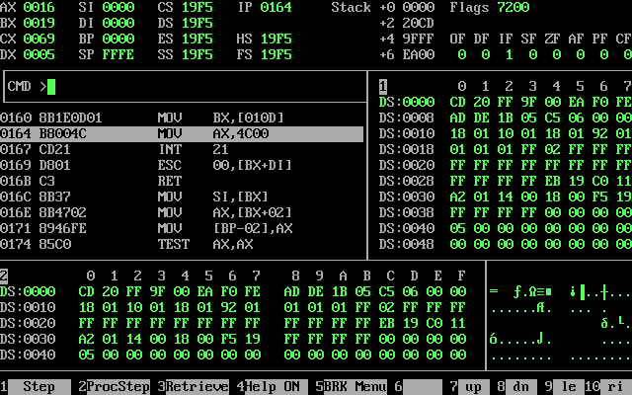

Activity 2

Assembly Language Code
[org 0x0100]

jmp start

d1: dw 0
d2: dw 0
d3: dw 0
d4: dw 0

Digit_Seperator:
push bp
mov bp, sp
mov ax, [bp+4]
mov bx, 0x10
div bx
mov [d1], dx
div bx
mov [d2], dx
div bx
mov [d3], dx
div bx
mov [d4], dx
pop bp
ret 2

start:

mov ax, 0x5692
push ax

call Digit_Seperator

mov ax, [d1]
mov bx, 0x10
mul bx
mov cx, [d2]
add ax, cx
mov bx, 0x10
mul bx
mov cx, [d3]
add ax, cx
mov bx, 0x10
mul bx
mov cx, [d4]
add ax, cx

mov bx, 0x5692

mov ax, 0x4c00
int 0x21

Debugging Screenshots
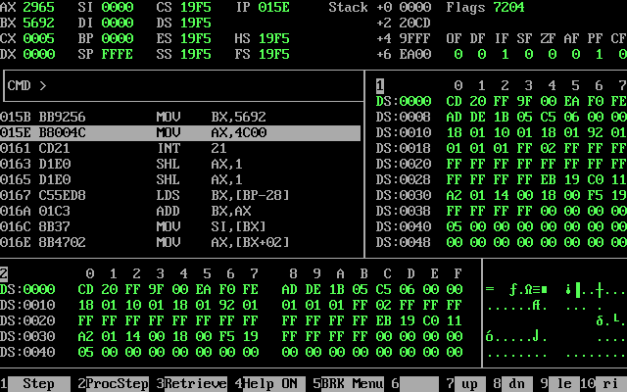

Activity 3

Assembly Language Code
[org 0x0100]

jmp start

l1: dw 0
l2: dw 0
l3: dw 0
s1: dw 0
PF_Array: dw 566, 189, 243, 60, 131, 403, 238, 612, 32, 26, 285, 501, 503, 241, 758, 98, 380, 545, 99, 659, 652, 580, 232, 530, 956, 701, 790, 967, 958, 745, 341, 400, 988, 20, 384, 571, 126, 886, 549, 983, 619, 876, 369, 221, 474, 818, 900, 983, 178, 176, 824, 188, 141, 467, 128, 705, 200, 885, 647, 841, 571, 551, 909, 499, 456, 796, 766, 530, 68, 51, 559, 927, 444, 188, 452, 688, 526, 307, 267, 572, 315, 512, 481, 824, 72, 905, 581, 937, 300, 42, 31, 914, 971, 872, 633, 632, 794, 666, 406, 133

findlargest:

mov si, 0

l100:

mov ax, [PF_Array+si]
cmp ax, [l3]
ja swap
l101:
add si, 2

cmp si, 198
jne l100

ret

start:

call findlargest
mov ax, [l3]
mov [l1], ax

mov si, [s1]
mov word[PF_Array+si], 0

call findlargest
mov ax, [l3]
mov [l2], ax

mov si, [s1]
mov word[PF_Array+si], 0
call findlargest

mov ax, [l1]
mov bx, [l2]
mov cx, [l3]

mov ax, 0x4c00
int 0x21

swap:
mov [s1], si
mov [l3], ax
jmp l101

Debugging Screenshots
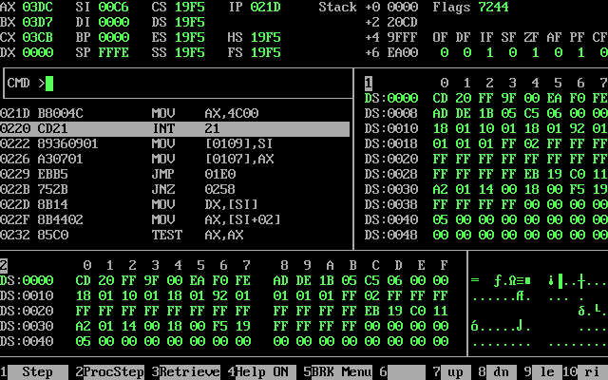

Activity 4

Assembly Language Code
[org 0x0100]

jmp start

PF_Array: dw 566, 189, 243, 60, 131, 403, 238, 612, 32, 26, 285, 501, 503, 241, 758, 98, 380, 545, 99, 659, 652, 580, 232, 530, 956, 701, 790, 967, 958, 745, 341, 400, 988, 20, 384, 571, 126, 886, 549, 983, 619, 876, 369, 221, 474, 818, 900, 983, 178, 176, 824, 188, 141, 467, 128, 705, 200, 885, 647, 841, 571, 551, 909, 499, 456, 796, 766, 530, 68, 51, 559, 927, 444, 188, 452, 688, 526, 307, 267, 572, 315, 512, 481, 824, 72, 905, 581, 937, 300, 42, 31, 914, 971, 872, 633, 632, 794, 666, 406, 133
swap: db 0

bubblesort: dec cx ; last element not compared
shl cx, 1 ; turn into byte count
mainloop: mov si, 0 ; initialize array index to zero
mov byte [swap], 0 ; reset swap flag to no swaps
innerloop: mov ax, [bx+si] ; load number in ax
cmp ax, [bx+si+2] ; compare with next number
jbe noswap ; no swap if already in order

mov dx, [bx+si+2] ; load second element in dx
mov [bx+si], dx ; store first number in second
mov [bx+si+2], ax ; store second number in first
mov byte [swap], 1 ; flag that a swap has been done
noswap: add si, 2 ; advance si to next index
cmp si, cx ; are we at last index
jne innerloop ; if not compare next two

cmp byte [swap], 1 ; check if a swap has been done
je mainloop ; if yes make another pass
ret ; go back to where we came from

start:

mov bx, PF_Array ; send start of array in bx
mov cx, 100 ; send count of elements in cx
call bubblesort ; call our subroutine
call clrscr
mov di, 500
mov si, 0

mov ax, 0xb800
mov es, ax
l1:
mov ch, 0x07
mov cl, byte[PF_Array+si]
mov [es:di], cx
add si, 2
add di, 4
cmp si, 198
jne l1

mov ax, 0x4c00
int 0x21

clrscr: push es
push ax
push di
mov ax, 0xb800
mov es, ax ; point es to video base
mov di, 0 ; point di to top left column
nextloc: mov word [es:di], 0x0720 ; clear next char on screen
add di, 2 ; move to next screen location
cmp di, 4000 ; has the whole screen cleared
jne nextloc ; if no clear next position
pop di
pop ax
pop es
ret

Debugging Screenshots
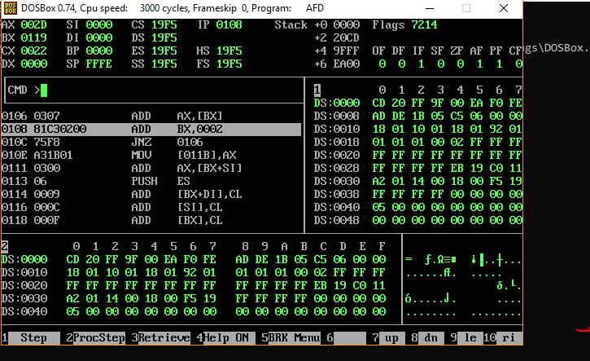

Activity 5

Assembly Language Code
[org 0x0100]; we will see org directive later
mov ax, 5 ; AX = 5
mov bx, 10 ; BX = 10
add ax, bx ; AX = AX + BX
mov bx, 15 ; BX = 15
add ax, bx ; AX = AX + BX
mov ax, 0x4c00 ;terminate the program
int 0x21

Debugging Screenshots

